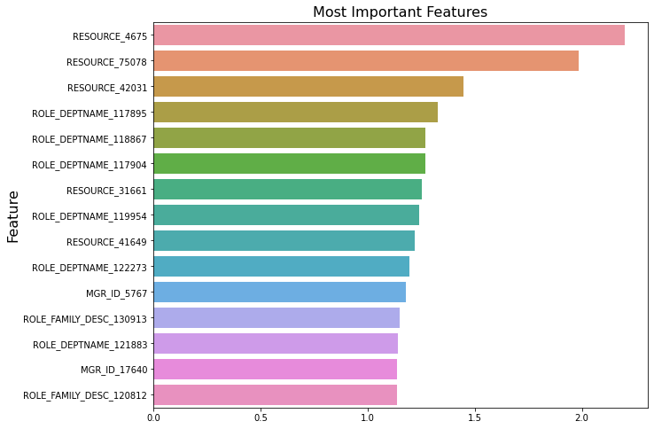

Features obtained by Logistic regression

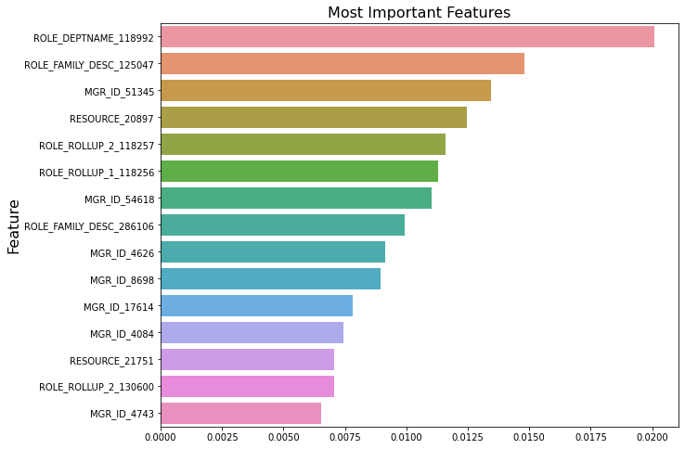

Features obtained bt Random Forest

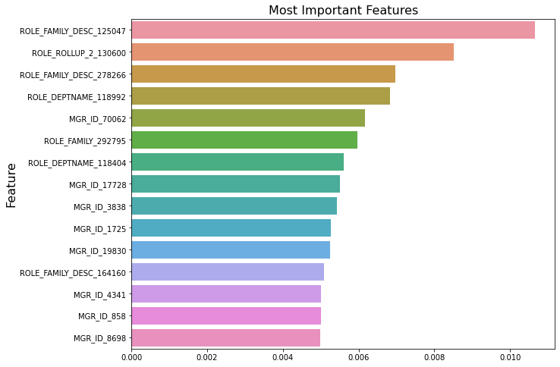

Features obtained bt XGBOOSTER Classifier

//////////////////////////////////////////////////////////////////////////////////////////////////////////

.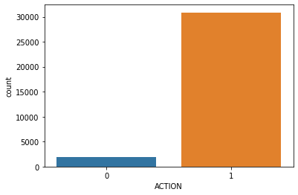

We can see that we have imbalance dataset. There are very less records of not granting the access

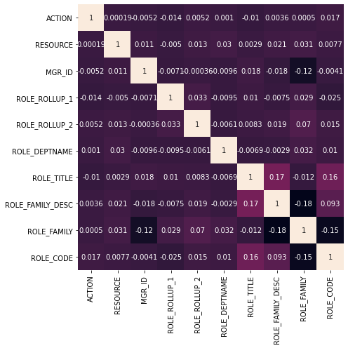

Correlation matrix/heat map of the features compared to each other

///////////////////////////////////////////////////////////////////////////////////////////////////////

AUCCRACY SCORE GRAPH OF VARIOUS ALGORITHMS

Explanation in the code

